IN-KIND SPONSORSHIP PLEDGE FORM

It’s your choice: DONATE your services directly, or UNDERWRITE any of these key aspects of
A Burlesque Ball and become an In-Kind UMLAUF Auction Sponsor.

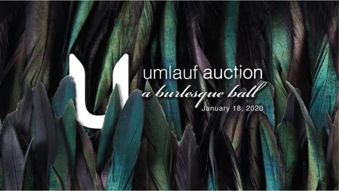
UMLAUF Auction: A Burlesque Ball
Saturday, January 18, 2020
7:00 – 11:00 p.m. at Sky Candy
1023 Springdale Road, Austin, TX 78721
www.umlaufsculpture.org/auction

IN-KIND SPONSORSHIP OPPORTUNITIES | EST. VALUE
Photobooth
Event Photography
Audio/visual
Floral
Décor
Lighting
Specialty cocktails
Karaoke After-Party
Dessert
Hand-Painted Masks
Print Collateral
Hors d’oevres
VIP Hors d’oeuvre
Silent Auction
Bubble Bustle Champagne Service
Custom Cotton Candy

- ALL IN-KIND SPONSORS RECEIVE:
- Logo and name recognition on signage at A Burlesque Ball, and on the UMLAUF Auction event webpage, digital marketing and social media, seen by over 10,000 followers.
- Verbal Recognition as Auction Sponsors at “A Burlesque Ball”
- Donations valued over $2,500 entitle Donors to 2 GA Tickets to Garden Party 2020
- Donations valued over $5,000 entitle Donors to 2 VIP Tickets to Garden Party 2020

THANK YOU FOR SPONSORING THE UMLAUF AUCTION 2020: A BURLESQUE BALL

The UMLAUF Sculpture Garden and Museum is a 501(c)3 nonprofit organization. Your sponsorship is partially tax-deductible.
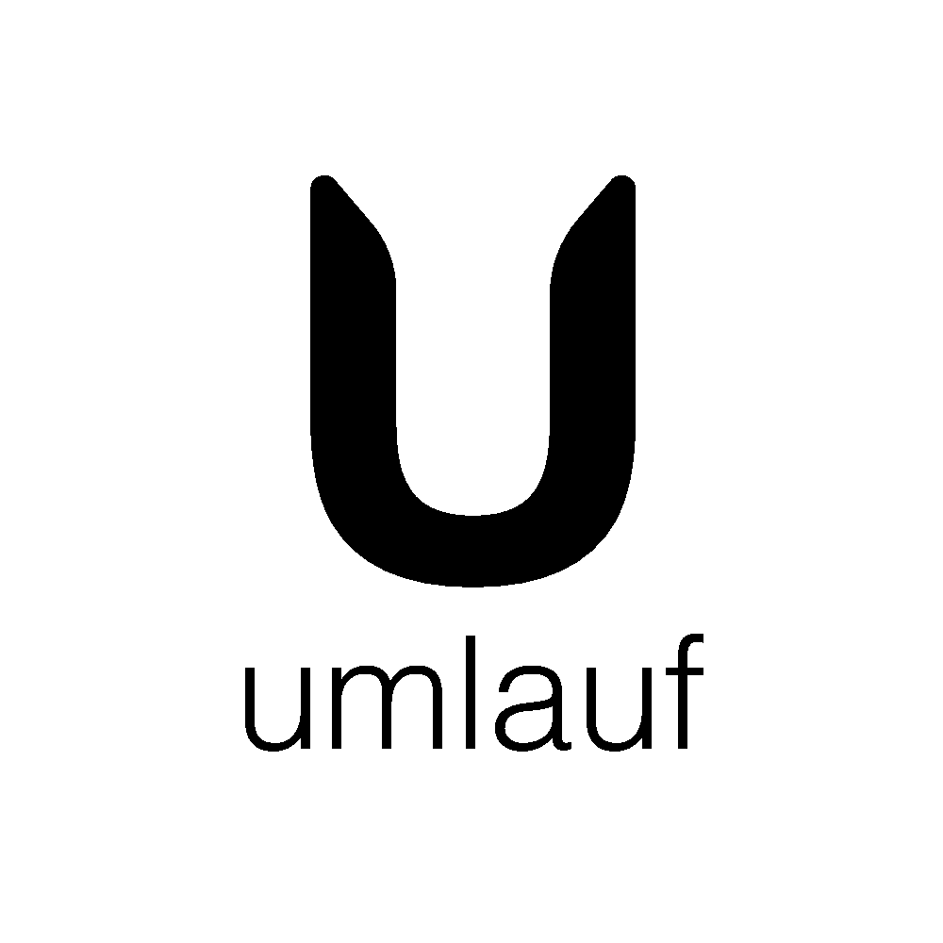
IN-KIND SPONSORSHIP PLEDGE FORM

Description of Item for Sponsorship or Donation: _________________________________
Cash Value of In-Kind Sponsorship or Donation: __________________________________

CONTACT INFORMATION

Name or Name of Company: ______________________________________________________
Address: ______________________________________________________________________
City: _____________________________________ State: _____________ Zip: ______________
Contact Name:__________________________________________________________________
Phone: (_______) ______________________ Email:___________________________________

RECOGNITION OF SPONSORSHIP

Official Listing for Sponsorship Recognition: __________________________________________
___ I/we prefer not to be listed
___ I am sorry I will not be able to attend but please accept my gift of $ ________________

PAYMENT INFORMATION
(All payments are due in full by December 18, 2019)

___Payment in full by enclosed check (payable to the UMLAUF Sculpture Garden and Museum)
___The UMLAUF will receive my payment by check on ______________.
___Payment in full by credit card
Credit Card #: ___________________________________CVV # ________ Exp. Date: ____/ ______

Signature: ________________________________________________ Date: _______/ _______

Please return completed forms to:

UMLAUF SCULPTURE GARDEN + MUSEUM
Attn: Dalya Sachs, Senior Development Manager
605 Azie Morton Road, Austin, TX 78704
510-919-4454 // dalya.sachs@umlaufsculpture.org

